Ni'gel
Ability | Score | Modifier
Strength | 14 | +2
Dexterity | 18 | +4
Constitution | 12 | +1
Intelligence | 10 | +0
Wisdom | 16 | +3
Charisma | 8 | -1
Stat | Value
Armor Class | 18
Initiative | +4
Speed | 30 ft
Hit Points | 38 / 38
Hit Dice | 5d10
Proficiency Bonus | +3
<center> </center>
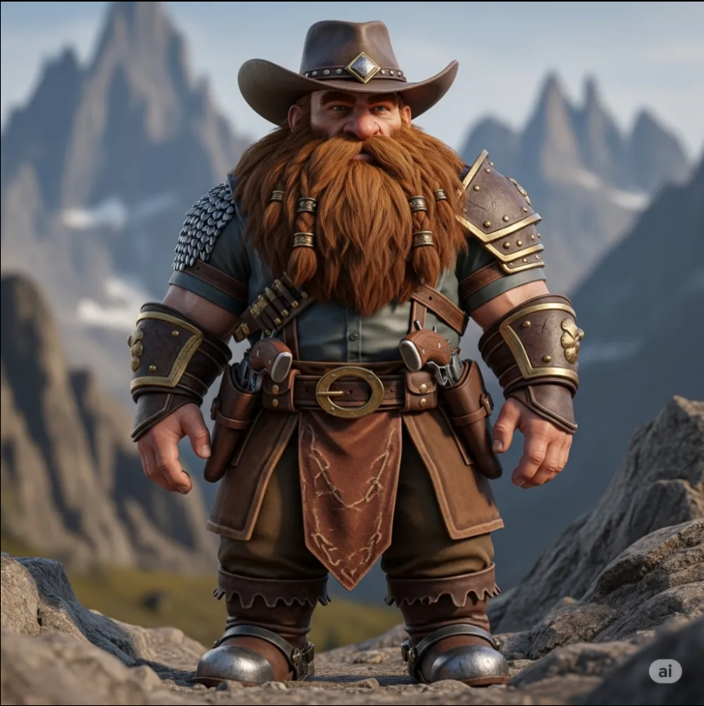Nigiel Portrait
Race:
Class:
Background:
Alignment:
Level:
Name | Attack Bonus | Damage/Type
Longbow | +7 | 1d8+4 piercing
Shortsword | +5 | 1d6+2 slashing
- Explorer’s Pack
- Longbow (20 arrows)
- Shortsword
- Leather Armor
- Trinket: Feather from a griffon
<!– Add lore content here –
>
</panel> <panel type="info" title="🧾 Info"> <!-- Add additional metadata or notes here --> </panel>

