Gurghh
Gurghh is the main character of the Gurghh'y'verse
</col>
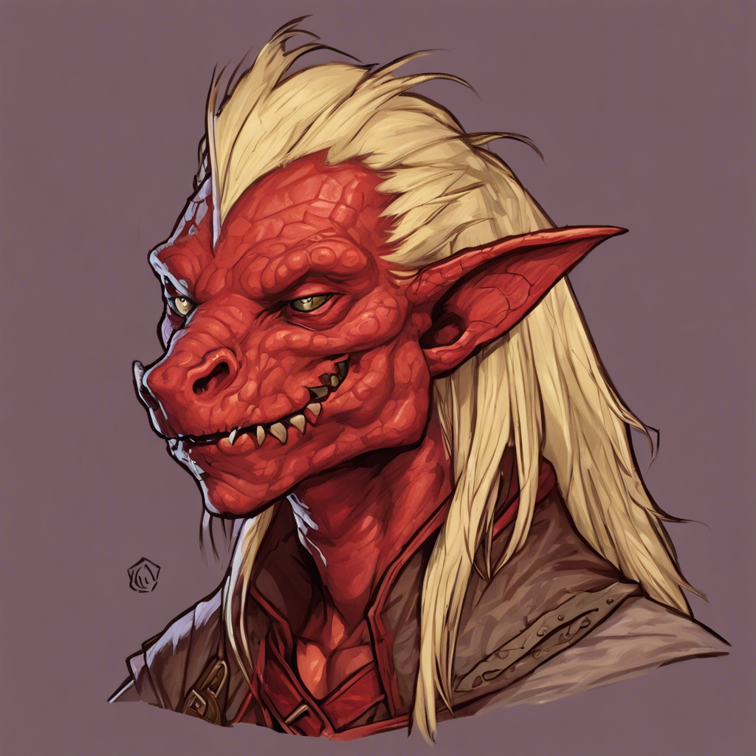
Name: Gurghh
Age:
Saltmarsh- 25
Strahd- 67
Race: Kobold
Colour: Red
</col>
<!– Add additional metadata or notes here –
>
</panel> <panel type="info" title="🧾 dimension rip"> <!-- Add additional metadata or notes here --> </panel> <panel type="info" title="🧾 Borovia"> <!-- Add additional metadata or notes here --> </panel> <panel type="info" title="🧟 Kobold"> {{url>https://wiki.liamgore.co.uk/statblock.php?id=kobold_mm 100%,400 noborder center|Kobold Stat Block}} </panel> {{include>includes:monsterblock&name=Kobold&id=kobold_mm}}

